March 15, 2013

for your Information

FREE Subscription

On our www.eresearch.ca website, our Research is FREE. To subscribe, all that is needed is an e-mail address.

For those of our readers who enjoy our newsletters, articles, and research reports, we would love to hear from you. All messages are answered.

Also, if you like what you read, we would appreciate it if you would pass on the availability of our service to your friends.

###

Topic: Natural Gas

For quite a while, natural gas performed so badly, with the price beaten down because of the tremendous new supplies found in the United States, and which are accessible because of evolving fracking techniques. As a substitute, especially for coal, natural gas all of a sudden came into sharp focus. After hitting a low of US$1.84 mmbtu last April, the price has more than doubled and currently (March 14) sits at US$3.74 mmbtu.

The first chart shows the trend in the ratio of crude oil to natural gas. At the last significant market low, on October 1, 2011, the ratio was 21.58x. The current ratio (March 14, 2013) is 24.87x. It had reached a high of 56.01x when the price bottomed out in April, 2012.

October 1, 2011 - March 1, 2013




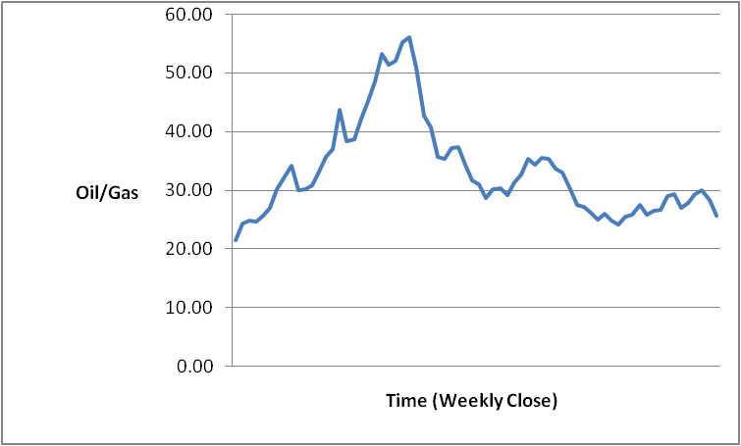

The second chart, on the next page, compares the relative performance of oil versus gas to their respective prices on October 1, 2011. Oil has out-performed over the period but, since April, gas has almost closed the gap.

October 1, 2011 - March 1, 2013

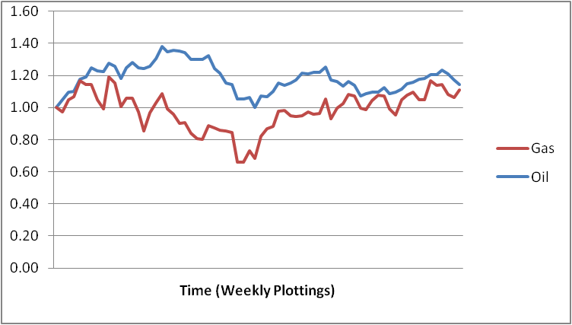

The average price of natural gas since October 1, 2011 is US$2.98 per mmbtu. (The current price is US$3.74 per mmbtu, up from an April low of US$1.84 per mmbtu, and trending higher lately.)

The following table shows the trend in natural gas on a quarter-by-quarter basis.

Average Price per MMBTU (US $)

 | Q1 | Q2 | Q3 | Q4
2010 | $5.07 | $4.30 | $4.32 | $3.75
2011 | $4.15 | $4.31 | $4.12 | $3.31
2012 | $2.39 | $2.31 | $2.88 | $3.24
2013 | $3.36*

* So far in Q1/2013, the average price has been US$3.36 mmbtu.

The price of natural gas has been out-performing oil over the past four weeks. If recent trends can be sustained, then the average price for 2013 could get back to 2010 levels. If so, this could give continuing momentum to those beaten-down natural gas stocks that are starting to show some life.

Bob Weir, CFA, and Director of Research

New eResearch Material Since
March 1, 2013:

- Reports

Century Iron Mines Corporation
03/11/2013

H2O Innovation Inc.
03/09/2013

2. Analyst Articles

Market Breadth

Technical Trends

Phases&Cycles

Stock Timing

Economic Talk

Feature Articles

In addition to these reports and articles, our full complement of research is available at www.eresearch.ca

BriefCase

NewsBytes from March 7 – March 15, 2013

Additional information on the companies featured in NewsBytes may be found at www.sedar.com, and at www.eresearch.ca.

For the latest eResearch publications, see sidebar opposite.
___________________________________________________________________
Strike Minerals Inc. ($0.035 - March 7, 2013; STK-TSX-V) …. Strike Minerals has published a development update for the Edwards mine project northeast of Wawa, Ontario. The Company continues to work on the underground development plan at the Edwards #1 and #5 delineated gold mineralized zones on the 60-metre level of the Edwards mine. Dewatering is at 140 metres, and underground development work continues to extend existing workings at the 60-metre and 90-metre levels. Drifting is planned to cut a number of mineralized zones where historical diamond drill holes have indicated high-grade gold values between surface and the 100-metre level. To date, development mining has produced and placed on surface around 1,100 tonnes of material with an average grade of 12.83 g/t from the Edwards #1 vein and 2,000 tonnes grading 2.0 g/t from other underground development.
___________________________________________________________________
Cadillac Ventures Inc. ($0.13 - March 14, 2013; CDC-TSX-V) …. Cadillac Ventures has published an update on its Burnt Hill property in central New Brunswick (51% interest; tungsten/tin). The Company has a preliminary resource estimate for the property (2009), calculated using historic drilling, limited drilling in 2007, and a resampling for verification purposes of the historic core. Subsequent to the 2009 resource calculation, Cadillac Ventures focused on its Thierry project (copper) near Pickle Lake in Ontario, and operations at Burnt Hill were limited. The Burnt Hill property was kept in good standing, and a future exploration plan was developed, aimed at further defining the deposit and moving the categorization of the resource from Inferred to Indicated by drilling certain areas of the deposit. Drilling was undertaken in 2011 and 2012. Assay results from the 2011 drilling campaign are included in the Company’s March 14, 2013 update, available on SEDAR.
___________________________________________________________________
SIR Royalty Income Fund ($12.24 - March 14, 2013; SRV.UN-TSX) …. SIR Royalty Income Fund (the Fund) and SIR Corp. (SIR) have closed the previously announced secondary offering by SIR of units of the Fund. Under the offering, a syndicate of underwriters purchased 895,000 units at $12.30 per unit, for gross proceeds of approximately $11 million. Following the closing, SIR now beneficially owns an aggregate of 2,187,951 Class A GP units, representing an equivalent beneficial ownership of 2,187,951 units, or approximately a 24.4% indirect interest in the Fund. The Fund did not receive any proceeds from the offering.

###

Opportunity Knocks

At the present time, eResearch has no analyst positions available, but we are looking for Business Development people on a commission-only basis.

If you are interested in learning more about eResearch, please contact Bob Weir at the following:
bweir@eresearch.ca.

“Research is the bedrock underpinning all capital markets”

Monthly Top Ten

The top-ten www.eresearch.ca downloaded reports since February 18, 2013:

- Precision Drilling Corporation, Phases & Cycles, February 20
- Microbix Biosystems Inc., Perspective, February 19
- H₂O Innovation Inc., StockPotentials, March 9
- Trinidad Drilling Ltd., Phases & Cycles, February 20
- Silver Wheaton Corp., Phases & Cycles, February 20
- Century Iron Mines Corporation, Perspective, March 11
- Bioniche Life Sciences Inc., Perspective, January 25
- Century Iron Mines Corporation, Update Report, February 2
- Cadillac Ventures Inc., Update Report, November 21
- Bioniche Life Sciences Inc., Perspective, December 28

Bi-Weekly Top Five

The top-five www.eresearch.ca downloaded reports since March 4, 2013:

1. H₂O Innovation Inc., StockPotentials, March 9
2. Century Iron Mines Corporation, Perspective, March 11
3. Precision Drilling Corporation, Phases & Cycles, February 20
4. Microbix Biosystems Inc., Perspective, February 19
5. Century Iron Mines Corporation, Update Report, February 2

Monthly Top-Five Requested Articles

The top-five www.eresearch.ca downloaded articles since February 18, 2013:

1. 2012 Charts, Phases & Cycles, February 20
2. Economic Straight Talk Newsletter, March 12
3. Global Energy Crisis, Oil & Gas Investor, February 19
4. Gold Mining Accounting, Jim Asset Management, March 1
5. Overbought VIX Indicator, Schaeffer’s Investment Research, March 12

